Chemistry 12 Equilibrium Test 2017
Total Marks____/ 52 Student Name:______________________

Multiple Choice Section:( 10 marks, 1 mark each )
Question 1:
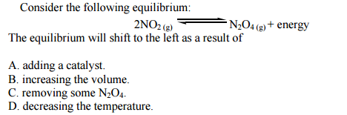

Question 2:
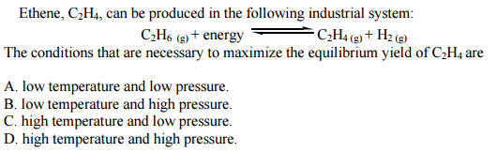

Question 3:
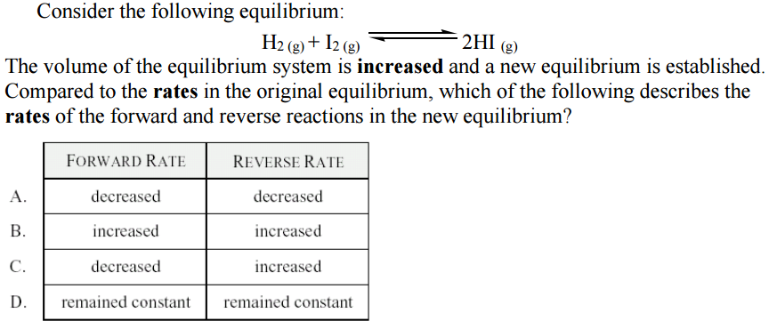

Question 4:
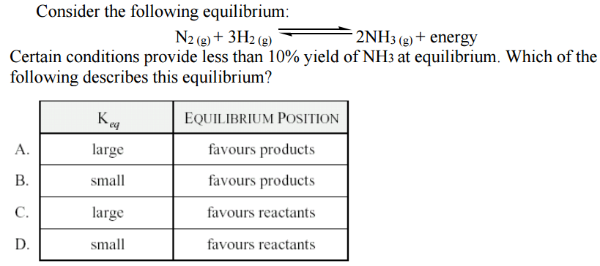

Question 5:
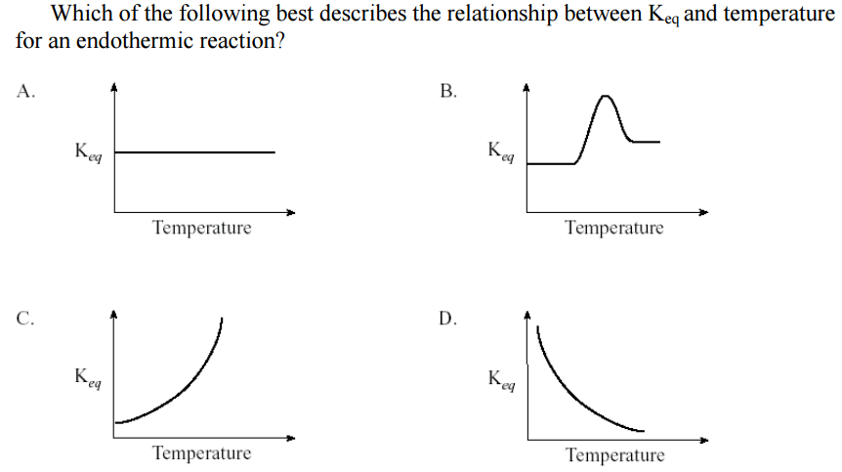

Question 6:
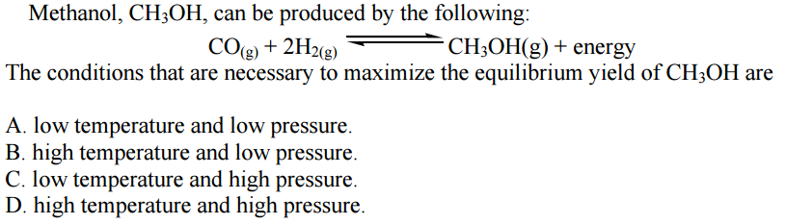

Question 7:
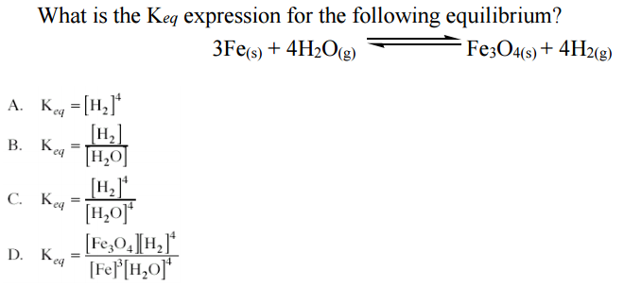

Question 8:
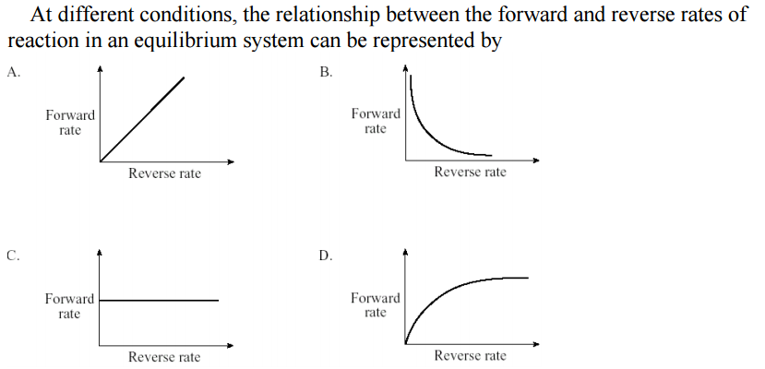

Question 9:
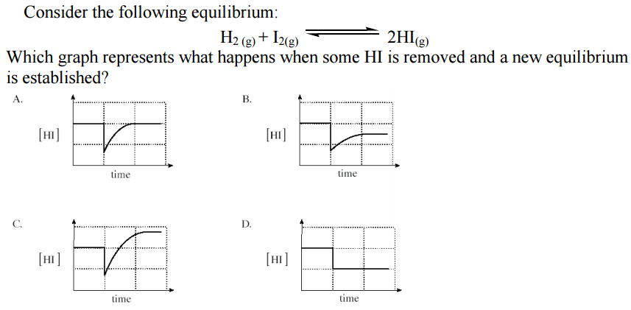
Question 10:
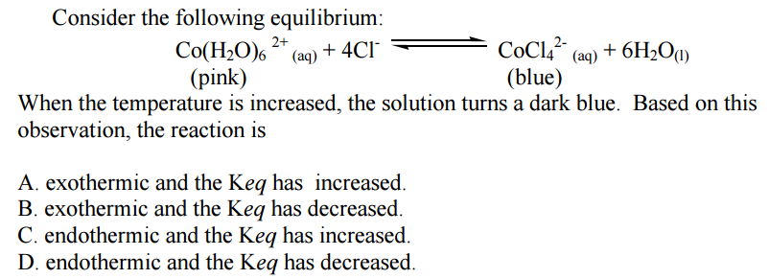

Written Answer Section:
Question 1:
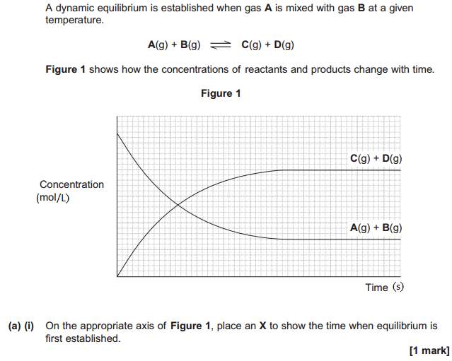
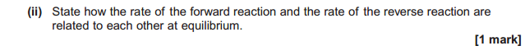
__________________________________________________________________________________
__________________________________________________________________________________

(b)Explain the meaning of the words “dynamic equilibrium”. Make sure to include collision theory in your explanation. [ 2 marks ]

__________________________________________________________________________________
__________________________________________________________________________________
__________________________________________________________________________________
__________________________________________________________________________________

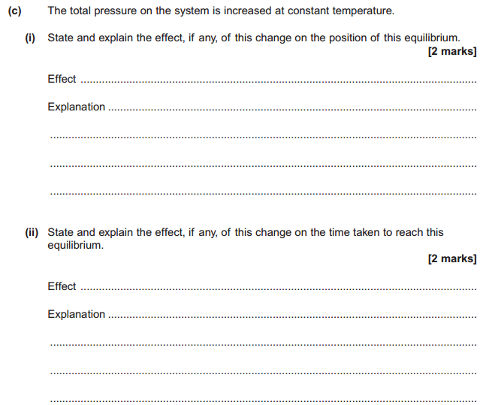

Question 2:
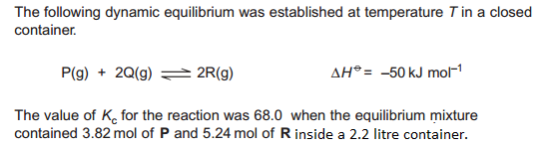

- Write the Keq equation then solve for the number of moles of Q inside the container when it was at equilibrium. [ 4 marks ]

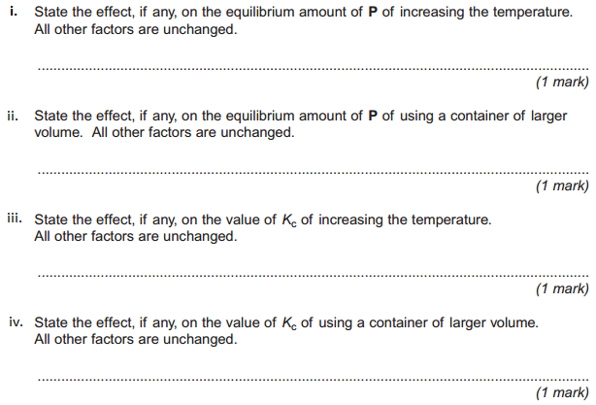
b)

Question 3:
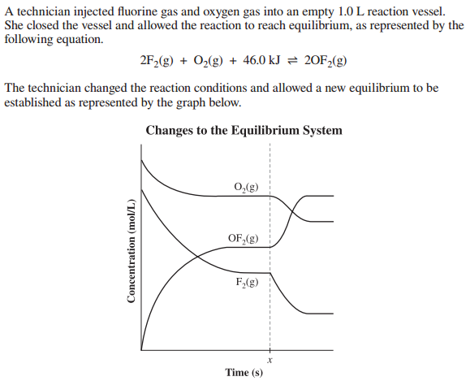
- What stress occurred to the system to result in the shifts in concentration observed above? [ 1 mark ]
_________________________________________________________________________________

- Describe at a molecular level, using collision theory, how this stress is causing the shifts in concentration of the reactants and products displayed in the diagram above. [ 3 marks ]

_________________________________________________________________________________
_________________________________________________________________________________
_________________________________________________________________________________
_________________________________________________________________________________
_________________________________________________________________________________

Question 4:
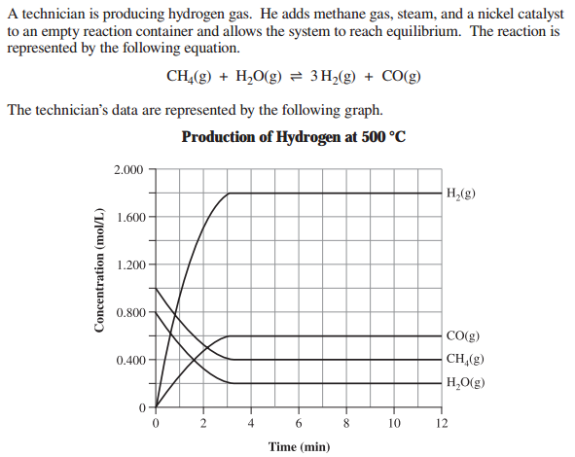
- Use the information on the diagram above to calculate the Keq value for this reaction. [ 2 marks ]

- If the concentration of only the carbon monoxide gas in the container was suddenly increase state whether this would increase, decrease or not affect the following things. Also provide a brief explanation using Le Chatelier’s Principle to explain your answer. [ 4 marks ]

- The concentration of hydrogen gas

__________________________________________________________________________________
__________________________________________________________________________________
- The value of Keq
__________________________________________________________________________________

__________________________________________________________________________________
__________________________________________________________________________________
Question 5:
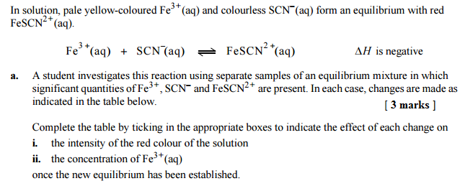
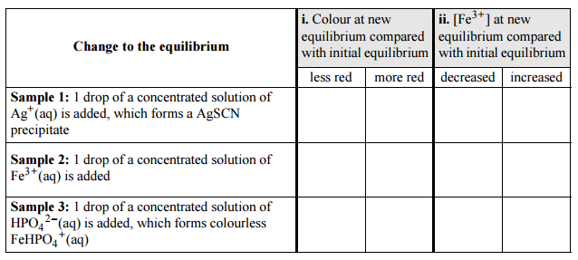
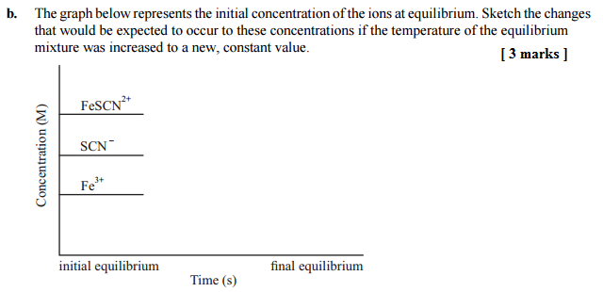

c. If equal amounts of aqueous Fe³⁺ and SCN⁻ are placed in a flask and allowed to reach equilibrium then are subjected to a temperature decrease draw the rate of reaction versus time graph for this situation. Start the graph where you only have reactants and finish the graph so that you once again have reached equilibrium after the disturbance.
Note: Make sure to label the forward and reverse reactions on the graph below. Use a solid line for the forward reaction and a dashed line for the reverse reaction. [ 4 marks ]

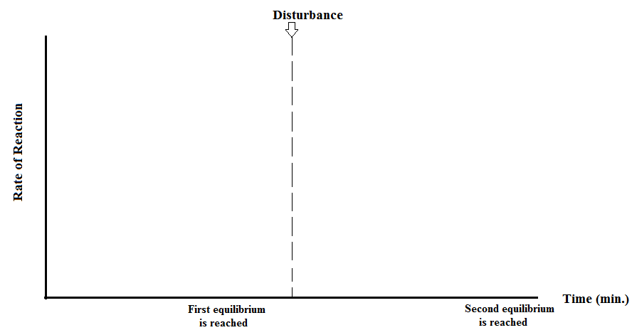

Question 6:
Consider the system shown in the diagram, where a solute solution equilibrium has been established in a beaker. Briefly explain the following:
a) State two ways by which the equilibrium could be altered. [ 2 marks]
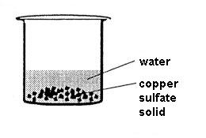
______________________________________________________________________________________________________________________________________________________________________________________________________________________________________________________________________________________________________________________________________________

Question 7:
The equilibrium between Mg(OH)₂ and its ions in aqueous solution can be represented by the following equation: [4 marks]

Mg(OH)₂(s) <==> Mg²⁺(aq) + 2OH⁻(aq)
White colourless solution
At equilibrium, the white solid is present in a colourless solution.
two test tubes are set up, each containing the equilibrium mixture. Each of the test tubes is treated as described below. In each case state what will be observed, how the equilibrium will shift and what happens to the concentrations of the ions asked about.

What is done? | What is observed? | How the equilibrium shifts? Write  ‘→’,’←’ or  ‘no change’ | What happens to the concentration of Mg²⁺.  Write increase, decrease or  no change | What happens to the concentration of OH⁻.  Write increase, decrease or  no change
A little water is added to the first test tube
A few drops of 1.0 molL⁻¹ hydrochloric acid solution are applied to the second test tube

